

**Ganpat University (ICT)**

**X**

**Karma foundation**

**Societal Internship**

**Day-1 Report**

**Topic name: - Sahara**

**Group Members**

Patel Vishva RakeshBhai (24162172012)

Contractor Heet PrakeshBhai (24162582003)

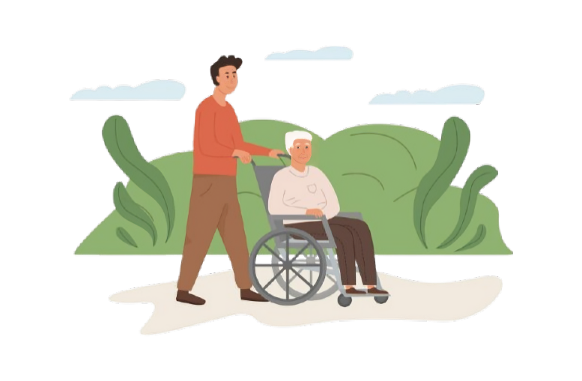Day-1 Report

|  |  |
| --- | --- |
| Location: | Sheh Kutir old Age Home |
| Date: | Dec 3rd |
| Time: | 09:00 AM – 11:30 AM |

**schedule**

|  |  |
| --- | --- |
| 09:00 AM | Entered and got connected with Old aged Members |
| 09:45 AM | Waited for the Head staff to Arrive |
| 10:15 AM | Talked to the Head staff |
| 11:00 AM | Took some pictures |
| 11:30 AM | Left the old age Home |

|  |
| --- |
| **Important Information** |
| The old Age home is registered  Regi. No. :- E/3478 | |

|  |
| --- |
| **Questions** |
| Q1. How old the Old age Home is?  Ans. 15 Years (2009) | |
| Q2. What is the age Range & Heath Condition of the resident ?  Ans. Age Range :- 65 Years Old , Health Condition 90% resident has good health. | |
| Q3. What is the Staff to Resident ratio ?  Ans. 7:70 (7 Staff, 70 Resident) | |
| Q4. What Facilities are currently available ?  Ans. Garden, Television, etc. | |
| Q5. Are there any regular medical check-ups on health program for resident ?  Ans. 2-3 Months (Medical Camp) | |
| Q6. Is there any activities organized for the Resident ?  Ans. Bhajan, Yoga, Pravas (by Donors). | |
| Q7. What are the primary source of funding for the vrudhashram ?  Ans. Donations. | |
| Q8. What are the current challenges faced in term of finance and resources ?  Ans. At Starting there is no harsh challenges getting faced now. | |
| Q9. How do you prioritize the use of funds received from Donors ?  Ans. Repairing Building as per Req. , Growing Plants, foods, etc | |
| Q10. What are the most urgent needs of your vrudhashram right now ?  Ans. Sing and Cottonseed, etc Oils (Oil can be of anytype that Donor are willing to donate) (6 cans per Month ) | |
| Q11. Are there any specific projects on upgrade are planning for resident ?  Ans. Building Staff room. | |

|  |
| --- |
| **requirements** |
| 1. Sing and Cottonseed, etc Oils (Oil can be of anytype that Donor are willing to donate) (6 cans per Month ) 2. Building Staff room. | |

|  |
| --- |
| **Contact Information** |
|  | |
|  | | |
| **team Picture** | |
|  | |
| **Olg age Home Pics** | |
|  | |